Specialized gymnasium for gifted children named after Kanysh Satpayev, Aksu city

Kaztay Alizhan,Nuridenov Mansur,Zhalel Ulan

10th-grade students

Topic: Creating a portable medical device that monitors the health effects of sunlight based on an actinometer built on Arduino

Section: Hardware control

Supervisor: Atik Bibigul Vasilievna - physics teacher

Astana city 2026

Content
Annotation:
KZ_______________________________________________________________3
EN_______________________________________________________________4
Introduction________________________________________________________5

Research section
1.1. The impact of sunlight on nature ___________________________________6
1.2. The impact of solar activity on humans______________________________7-8
2.1. Actinometer and types of actinometers ______________________________9-12
2.2. Solar activity monitoring tool using an actinometer created on the LEGO Mindstorms platform ________________________________________________________________12-13
2.3. Analysis of the features and disadvantages of ESP32 and Arduino Uno with the LEGO Mindstorms platform in the creation of an actinometer prototype_________________________________________________________13
2.4. Creating an actinometer prototype based on ESP32 and Arduino Uno _____13-14
Conclusion _______________________________________________________15
References _______________________________________________________16
Comment_________________________________________________________17

Аннотация
Бұл жобаға қызығушылық жоғары сынып оқушысы, бүгінгі күні гимназия түлегі Хасенов Аспандиярдың LEGO Mindstorms-да жасаған актинометрмен танысқан соң пайда болды. Күнде болып жатқан процесстер бізді көп қызықтыратын, күн белсеңділігі, оны қалай бақылауға болатынын және тұрмыста қалай қолданатынын зерттеуге кірістік. Күн белсеңділігін және оның Жермен адамға әсерін зерттеу кез-келген уақытта маңызды, себебі Жер атмосферасымен Жердің магнит өрісіне Күннің әсері зор, ол магнит толқу, радиобайланысқа әсері, метеорологиялық өзгерістер, адам ағзасында тудыратын өзгерістер. Осы өзгерістерді уақытында танып-біліп, зияңды әсерін азайтуға болады деп болжам жасадық. ESP32 және ARDUINO UNO жиынтығын күн белсеңділігін бақылайтын құрылғы актинометрді жасадық. Актинометрді тұрмыста күн белсенділігі артқан кезде, адамдарға зиянды әсерін азайту шараларын орындауға мүмкіндік береді деп есептейміз мәселен, ақшыл киім кию, көзілдірік кию, созылмалы аурулары бар адамдарға далаға аз шығу т.с.с. Жасаған актинометр ESP32 және ARDUINO UNO жиынтығының температуралық датчик(DHT11), ESP32 платасы, Мама-Папа,Мама-Мама сымдары қолданылды. Термометр көмегімен анықталған температура арқылы формуланы қолданып, күннің белсенділігі есептелініп, қорытыңды жасалады.
Сонымен біздің жұмысымыздың өзектілігі, ол күн белсеңділігінің адам ағзасына зияңды әсерін азайту мақсатында актинометр құрылғысын қолдану болып табылады.
Жұмыстың мақсаты:
Күннің белсеңділігінің табиғатқа, адамға әсерін зерттеу және актинометр құрылғысын қолдану.
Міндеттері:
1. Күн белсеңділігінің пайдасы мен қауіпін зерттеу
2. Актинометр құрылғысының түрлері мен жұмыс істеу принциптерін анықтау
3. Актинометрді тұрмыста қолдану аясын зерттеу
4. ARDUINO UNO көмегімен актинометр прототипін жасау.
Практикалық қажеттілігі Біздің жасаған актинометр прототипінің құрылысы қарапайым, жұмыс істеу принципі оңай ESP32 және ARDUINO UNO -да жасалған актинометр арқылы күн белсенділігін жоғарлағаның көріп, оның зияндылығы туралы хабар алған қолданушы күн белсеңділігінің зияңды әсерін мүмкіндігінше азайту іс-шараларын орындайды.

Annotation
The idea to create this project came after visiting an astronomical workshop. There, students in the field of space exploration, various projects motivated me to create one unique project in this direction. The topic of solar activity interested me the most, I began to study solar activity, how to control it and how to use it in everyday life. The study of solar activity and its influence on man with the Earth is important at any time, because the influence of The Sun on the Earth's magnetic field with the Earth's atmosphere is great, it is magnetic excitement, radio communication effects, meteorological changes, changes that cause in the human body. I assumed that by recognizing these changes in time, it would be possible to reduce the impact of damage. I created The set with an actinometer, a device that monitors solar activity. I believe that the actinometer allows you to perform measures to reduce the harmful effects on people when solar activity increases in everyday life, for example, wearing light clothes, wearing glasses, less going outside for people with chronic diseases, etc. With the help of a thermometer, using the temperature formula, the activity of the sun is calculated and summarized.
So, the relevance of my work is the use of an actinometer device in order to reduce the harmful effects of solar activity on the human body.
Purpose of the work:
The study of the influence of solar activity on nature, man and the use of an actinometer device.
Responsibilities:
1. study of the benefits and risks of solar activity
2. determination of the types and principles of operation of the Actinometer device
3. study of the scope of application of the Actinometer in everyday life
4.creating an actinometer prototype using ESP32 and ARDUINO UNO.
Practical necessity the construction of we prototype actinometer is simple, the principle of operation is easy the user who sees the increase in solar activity through the actinometer made in ESP32 and ARDUINO UNO and receives a message about its harm will take measures to minimize the harmful effects of solar activity as much as possible.

Introduction
Interest in this project arose after a high school student and today a graduate of the gymnasium named after Kanysh Satbayev got acquainted with the actinometer created by Khasenov Aspandiyar in LEGO Mindstorms. We began to study the solar activity, how to control it and how to use it in everyday life, which interests us most about the processes taking place in the sun. From various literature and internet resources, we wondered about the influence of the sun on nature, man in general, how to track the activity of the sun and where to use it. The study of solar activity and its influence on man with the Earth is important at any time, because the influence of The Sun on the Earth's magnetic field with the Earth's atmosphere is great, which is reflected in magnetic excitement, radio communication, meteorological changes, changes in the human body. I assumed that it would be possible to recognize these changes in time and reduce the impact of damage. As a new STEM classroom arrived at the gymnasium this year, our supervisor suggested using the ESP32 and ARDUINO Uno kit. We began to get acquainted with the set of ESP32 and ARDUINO UNO. We have developed an actinometer, a device that monitors solar activity. We believe that the actinometer allows people to take measures to reduce their harmful effects when solar activity increases in everyday life, for example, wear light clothes, wear glasses, and go outside less often for people with chronic diseases. The actinometer model developed by us is mainly used to measure the intensity of visible and ultraviolet rays. In meteorology, direct solar radiation is measured with it. In the manufacture of the actinometer, a circuit board of the ARDUINO UNO and ESP32 set, a layout circuit board, a temperature sensor, mama-mama, papa-papa, mama-papa were used. With the help of a thermodatchik, using a temperature formula, solar activity is calculated, summed up and adapted to comply with preventive measures for the harmful effects of the sun.

Research department
1.1 solar activity and its impact on nature.
The center of the solar system and the star closest to Earth is formed by the Sun, which gives energy in the form of light and heat, giving rise to the seasons, climate and ocean currents of the planet. In a word, it offers the First conditions necessary for life. The sun is the most important celestial object for living organisms. It is believed that it was formed about 5 billion years ago from a large cloud of stellar matter: gas and dust. These materials began to stick together due to the force of gravity.
Humanity has always been interested in studying the sun and has created many ways to study it. Basically, observation is carried out through telescopes, which have been on earth for a long time and are now also present on satellites. Many properties of the sun are known through light, such as spectroscopy, which allows us to know its composition thanks to the fact that each element leaves its own imprint.
From our point of view, the day seems very calm. But in fact, this is a place full of activity, where phenomena occur on an unimaginable scale. All changes that occur continuously in the sun are called solar activity. Solar activity-complex phenomena that occur periodically in the atmosphere of the sun. They are closely related to the magnetic characteristics of stellar plasma. When the sun's magnetic fields rise to the surface of the sun, various dynamic processes begin to occur, active zones are formed. All of them are an increase in solar activity. Many values are used to describe the level of solar activity, they are called solar activity indices. The most commonly used of them are wolf numbers: W = 10g + f, where g is the number of spot Groups, f is the full number of spots in the visible half of the Sun. Changes in solar activity occur periodically, due to changes in magnetic fields. These changes are of the following nature. Small-scale magnetic fields change not in order, but in a chaotic (chaotic) way. The sectoral structure of a field without symmetry in growth changes approximately with the period of rotation of the sun around its axis. And the poloidal and toroidal large-scale fields change quasiperiodically, with a period of about 22 years. The revolution of the dipole component and the exchange of Azimuth field direction occurs every 11 years. It is well known that an 11-year cycle is observed in changes in solar activity. Hale recorded the Zeeman classification of spectral lines in solar spots, one of the indicators of solar activity, and showed that the 11-year cycle of solar activity is part of the solar magnetic cycle with a period of ~22 years. Gradually, it became clear that all irregular phenomena on the surface of the sun and above the surface of the Sun are caused by magnetic fields emanating from the Sun's surface. At the beginning of its 11-year cycle, after a minimum of solar activity, away from the solar equator, at a latitude of ~300-400, sunspots are formed along with a strong azimuth magnetic field.
Explosions of solar activity can negatively affect the operation of communication systems, power lines. The navigation systems of aviation and space objects were disrupted, eddy currents were formed in Transformers and conductors.
The animal and plant world also depends on solar activity. It is in their highest values that locusts gather in hordes and increase the number of fish. Even Sable populations grow when the sun reaches its peak. The world ocean changes its temperature due to the activation of the star. Affects the development of marine plants and plankton.

1.2 the influence of solar activity on humans.
Since ancient times, scientists have been interested in the question of how The Sun affects human health. The ancient Egyptians also noticed that various changes occur in the sun, in connection with which the human condition also changes. The first information about sunspots dates back to 800 BC in China. Currently, the study of solar activity is becoming especially relevant, since the processes of change in the Sun are more active. A. L. Chizhevsky, who made a great contribution in this direction, showed that the largest and deadly epidemics were correlations between the Maxima of solar activity. These changes have a direct impact on the biosphere and, accordingly, on humans.
The effect of sunspots on humans was first discovered for patients suffering from one of the most common and dangerous types of cardiovascular pathology-myocardial infarction. This sudden onset of disease was compared to cosmic phenomena occurring on the Sun. 1 picture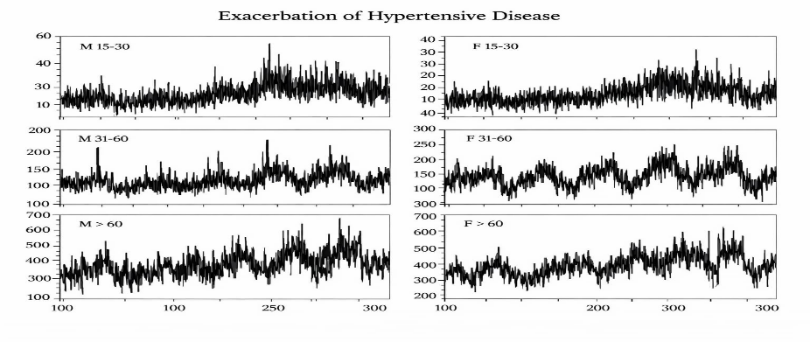
1st picture
One of the proofs of the effect of sunspots on the human body is the works of French doctors Sardou and for. As a result of nine months of observation of 298 patients, doctors came to the conclusion that the passage of spots through the central meridian of the sun coincides with 84% of the aggravation of various symptoms of chronic diseases and the appearance of serious complications. complications in the course of the disease. A parallelism was also found between the frequency of epileptic seizures and the appearance of sunspots. Thus, we can say that the appearance of spots directly affects various systems of human organs.2 picture
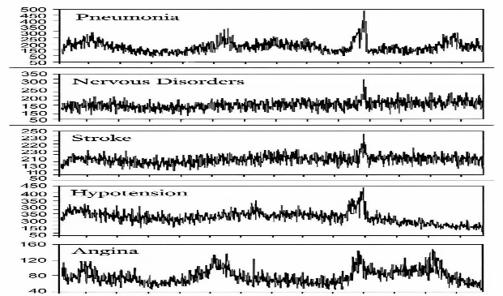
2nd picture
Another object of interest to many researchers is the solar flare, as it is the most powerful manifestation of solar activity affecting our planet. Flares are explosions on the surface of the sun caused by sudden compression of strong magnetic fields of plasma. As a result of such compression, a plasma tape is formed, the length of which is tens or hundreds of thousands of kilometers. Torches have a direct impact on a person's condition. Medical statistics show that on the day of the appearance of a solar flare, the number of people complaining of diseases of various systems increases by 1.5-2 times, as well as the number of deaths. The most unfavorable impact of storms in the Earth's magnetosphere falls on the cardiovascular system. During periods of turbulent geomagnetic conditions, subjective signs of a deterioration in the condition of patients appear, cases of increased blood pressure become more frequent, and coronary circulation deteriorates.
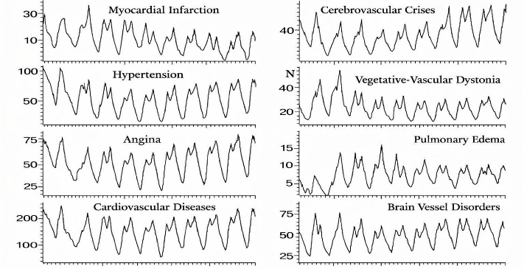
3rd picture
From this, The Sun significantly affects the functional state of a person. Solar flares and magnetospheric storms also have an equally powerful effect on the human condition.
On the impact of solar activity on a person, we conducted a survey among students and teachers of my school. We did the survey through the Google Forms Web page,where they were asked 4 questions.

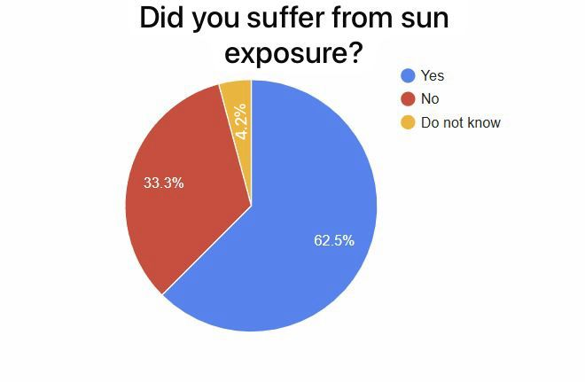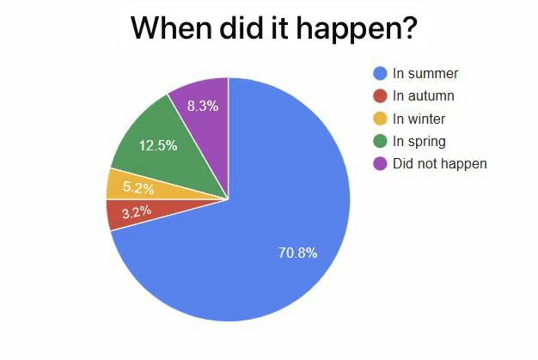
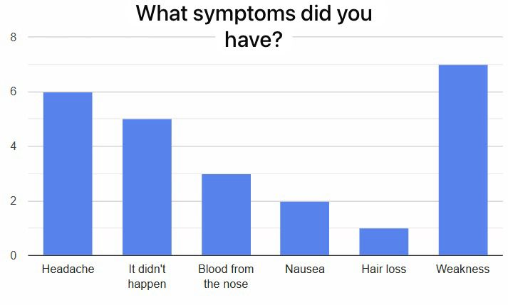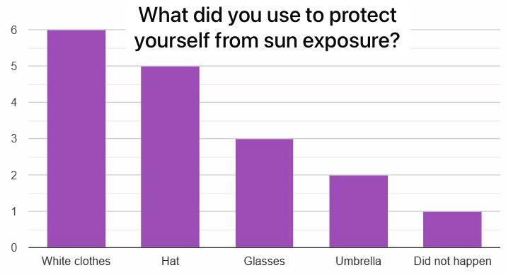

2.1. what is an Actinometer?
An actinometer is a measuring device that serves to measure the intensity of electromagnetic radiation, mainly visible and ultraviolet radiation. Instruments that measure the amount of radiant heat released into celestial space are called actinometers. To find solar activity, an actinometer is installed so that the receiving surface is turned to the side of the sky where there is no sun, the amount of heat lost is calculated by lowering the temperature. An ordinary actinograph is sometimes called an actinometer. The actinometer instrument was designed by Jules Violl and used to estimate the temperature of The Sun's surface. Actinometers are instruments for measuring heating. Also pyranometers, pyreliometers and radiometers are used in meteorology to measure solar radiation.
An actinometer is a chemical system or physical device that determines the number of photons in a beam integral or per unit of time. This name is usually applied to the devices used.
Types of actinometers:
The oldest actinographs were cylinders mounted on a horizontal axis, the rotation of which was provided by a clock mechanism and was surrounded by another stationary cylinder with a groove. The photo paper was glued to a rotating cylinder and, when passed through the opening, darkened, leaving a trace of insolation-dependent intensity. Such a device was described in 1845 by physicist Robert Hunt, Secretary of the Royal Polytechnic Society of Cornwall, as an improvement on the TB Jordan Heliograph (1839).

The actinograph (4image) is a device for recording the energy of solar radiation received on Earth, and the radiograph is the graphic output of the actinograph.
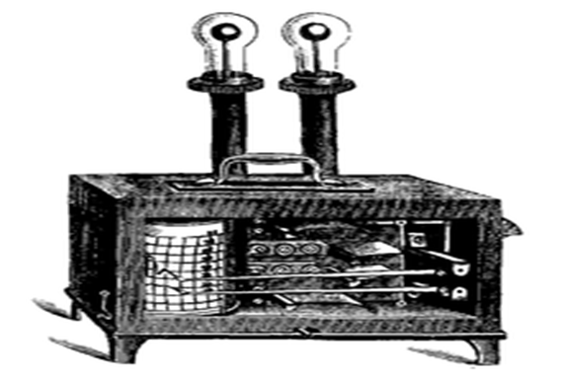
4 picture

Herschel actinometer. The most commonly used actinometer in England in the late 1870s was the Herschel thermometer(Figure 5). It consisted of a mercury thermometer with a spherical tank blackened by smoke and enclosed in an inflated glass tube with a small ball at the end. A vacuum is created in the shell around the thermometer, and the center of the flask coincides with the center of the tank.
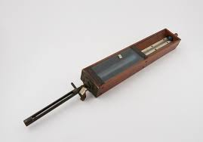
5 picture
In 1911, Arthur William Clyde of the Royal Meteorological Society and the director of the College of the Royal Albert Memorial University in Exeter, England, developed a version that allowed meteorologists to track daily shocks. His device used two springs, one of which was blackened and exposed to the sun, and the other was white and hidden, connected to each other. One suffered more expansion than the other, due to its heating, the tip of the stylus placed at their meeting point could draw a line on a piece of paper placed in a rotating drum, thus establishing the intensity of the radiation as a function. In 1926, Robitch developed an actinograph using the angular deviation of a dimmed bimetallic strip from a pyrheliometer.
Actinometer Violle (Figure 6) - the device consists of two concentric spheres, the inner part of which is kept at a constant temperature. This is possible by placing ice between two spheres (marked T and t' in the figure) or passing a stream of hot or cold water or even water vapor. Both shells have two holes on the same axis for the sun's rays to pass through the device, and the thermometer is placed in the center of the inner sphere through the hole (t') provided for this purpose. The correct position of the latter can be checked using a mirror attached to the support of the actinometer, to the place of the sun's Rays (at Point m). The temperature change in the thermometer is proportional to the light flux, which can be calibrated with a known source before taking any measurements. Viol used the empirical formula of Dulong and Petit, which predates Planck's law, to calculate the temperature of the sun's surface.
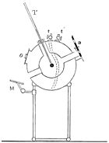
6 picture
Chemical actinometers-chemical actinometers [2] (Figure 7) provide energy flow by measuring the amount of sediments formed by the reaction of chemical compounds under the influence of sunlight. Therefore, in this case, it is important to know in advance the ratio of the formation of the deposit to the incoming energy. Potassium ferrioxalate is the most common compound in a chemical actinometer because it is easy to use and sensitive over a wide range of wavelengths (254 to 500 Nm). Other compounds such as green leukocyanides, vanadium(V)-fer(III) oxalates and monochloroacetic acid are sometimes used, but they also cause a reaction problem in the absence of light. For example, meso-diphenylhelianthrene is used for the visible spectrum (400 to 700 Nm).
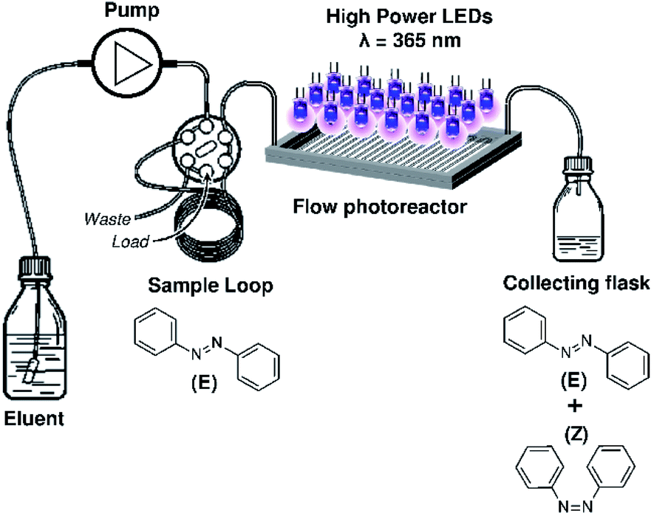
7 picture
Thermocouple actinometers [3] (Figure 8)- the receiving surfaces of actinometers in meteorology are protected by covers, the material of which simultaneously acts as a transparent filter only in the required wavelength range: from 0.3 to 3 microns for pyrgeliometers and pyranometers, up to about 0.1000 microns. As for the radiation sensors used in these instruments, they often use combinations of thermocouples capable of producing an electromotive force that varies depending on the light received.
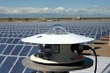
8 picture
There are four main types of pergeliometers and pyranometers:
1.Pyrgeliometers measure direct sunlight. They measure radiation that is constantly directed towards the sun and has not dissipated as it passes through the atmosphere;
2. pyranometric measurement of total solar radiation, that is, direct and diffuse, falling on a flat surface from all sides (usually directed horizontally and against the zenith);
3.in a pyrradiometric measurement of total radiation from a flat surface from all directions of the hemisphere, this radiation combines solar radiation (direct, diffuse and reflected upwards) and infrared radiation from the atmosphere and the Earth's surface.
4.still little used in Pyrgeometers, estimating the night infrared radiation obtained with a horizontal black surface. Depending on whether this surface is aimed at nadir or zenith, the measured illumination corresponds to terrestrial radiation or atmospheric radiation. The resulting radiation data (in joules per square meter) are used in various meteorological applications, such as potential evaporation and budget calculations of forest growth.
2.2 solar activity tracker via actinometer, developed on the LEGO Mindstorms platform.
The previous actinometer prototype was built from LEGO Mindstorms parts. The LEGO Mindstorms set used a servo motor, a module, the necessary parts, an optical mirror, wires and a thermometer.
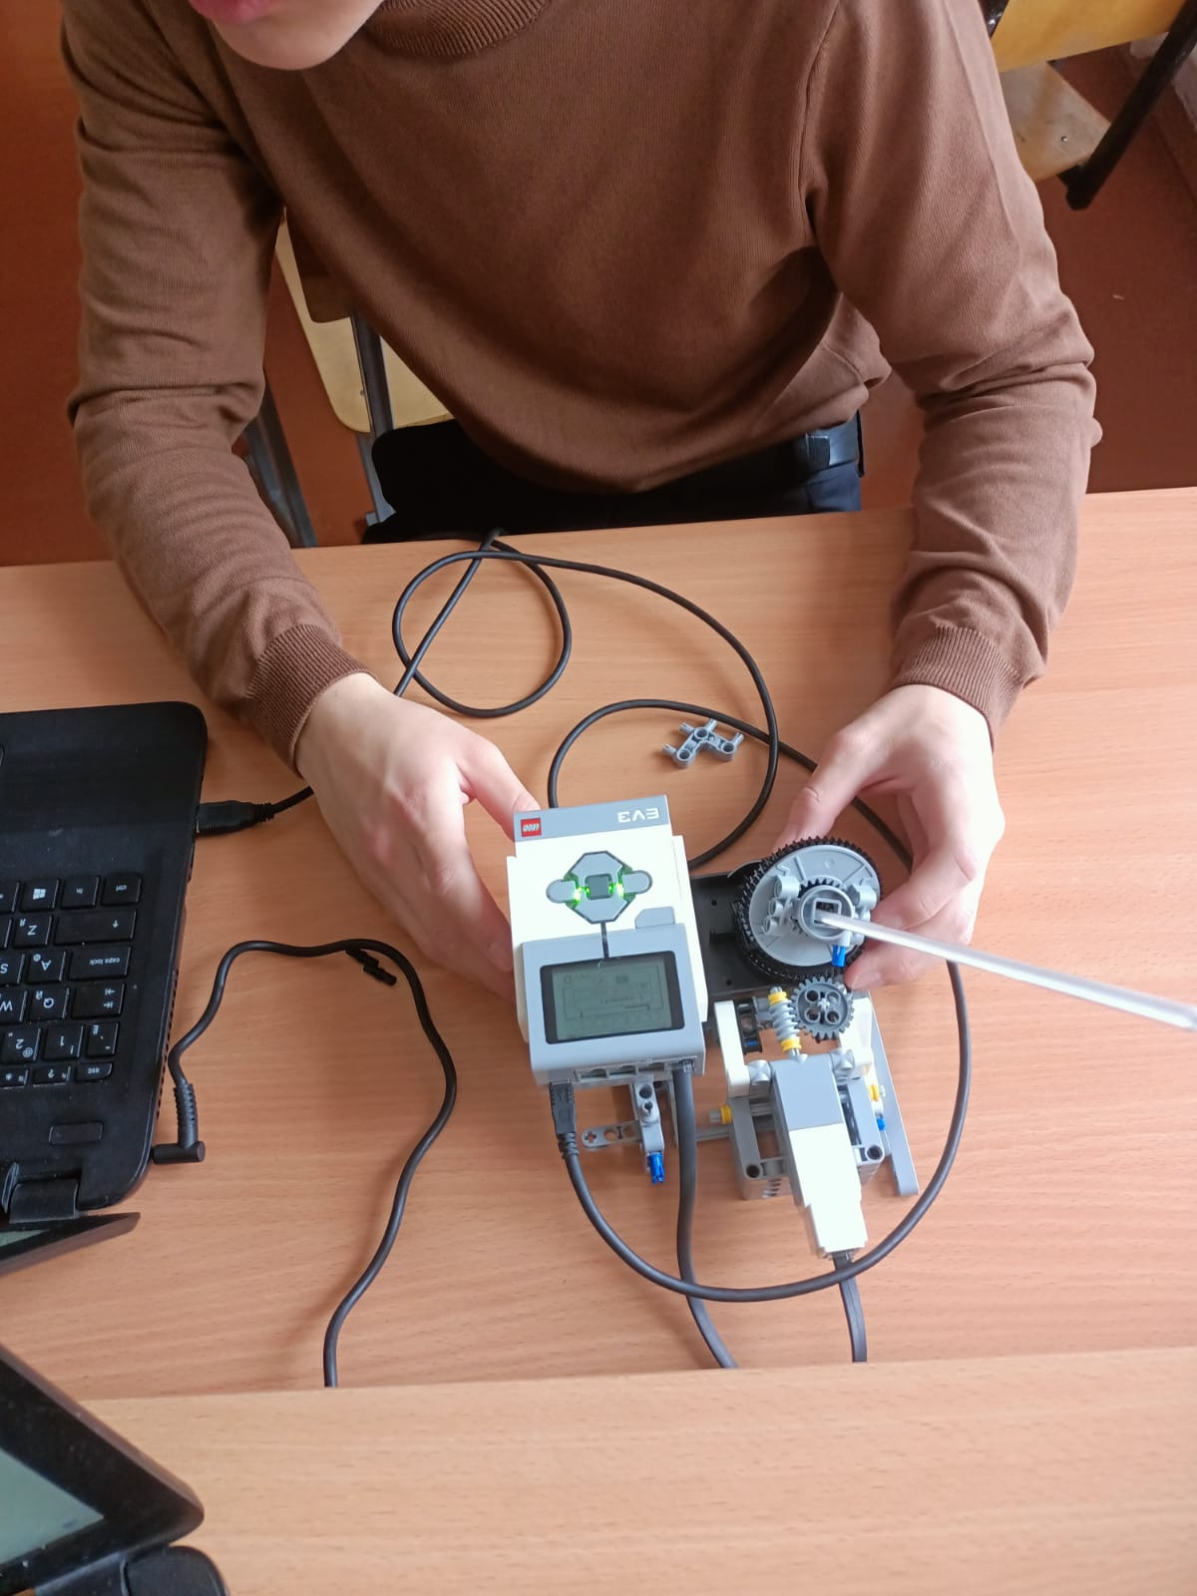
The Labview program was created if the reflection of sunlight with the help of an optical mirror, through an absolute black body, ensured that these rays remained in the same environment.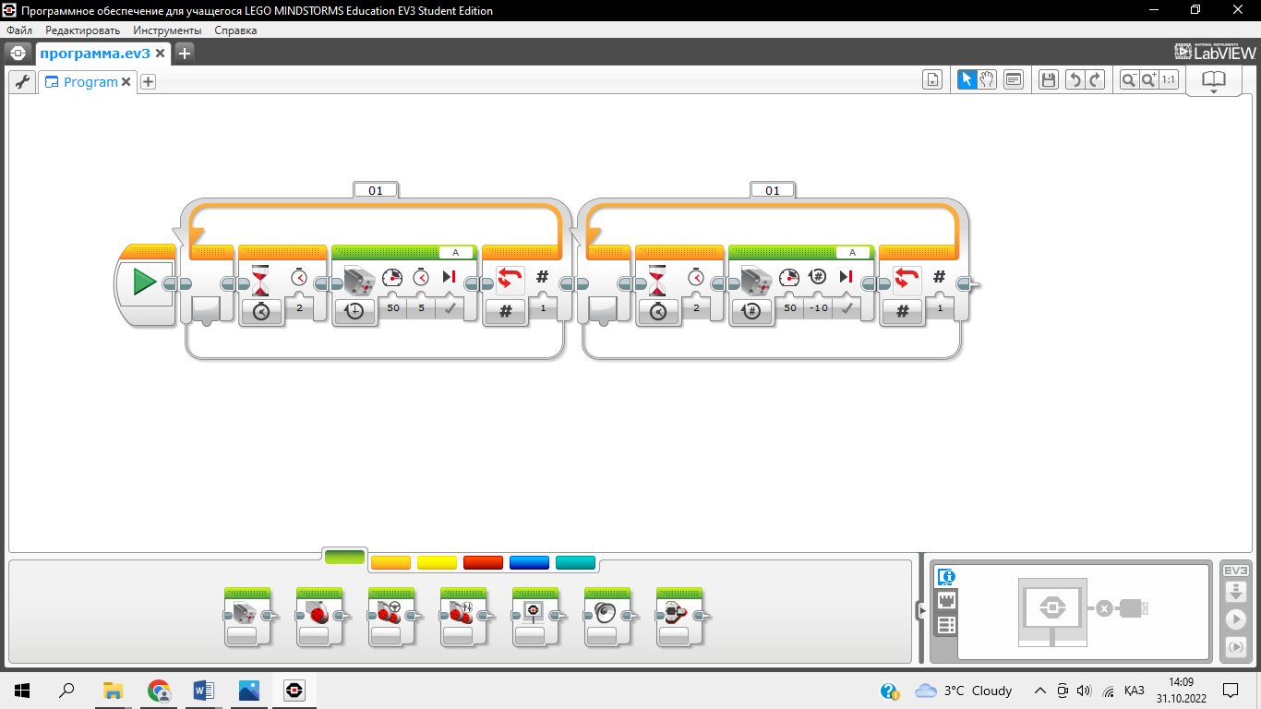

With the help of a thermometer, the activity of the sun was calculated and summarized by the temperature determined.
t = t _{с} $+$ $\frac{pQрад}{α н}$
t _{с} - outdoor air temperature
$\frac{pQрад}{α н}$- equivalent sunlight temperature
Q _{рад} - the amount of solar radiation falling on the surface (kcal / m2 · h)
α _{н} - heat transfer coefficient of the outer surface (kcal / m2 * h * deg)
J₁ = δ × S × s
δ - mirror solar radiation absorption coefficient
S - direct solar radiation [1]
S – mirror area
This device is used to detect increased solar activity and measure the intensity of visible and ultraviolet rays. According to the information provided, people are recommended to take the following measures to reduce the harmful effects:
- More restrictions on going outside;
-Wear light clothes, wear glasses, and wear a hat if you need to go outside;
- Holding an umbrella.

2.3 actinometer in the development of a prototype LEGO with the Mindstorms platform to analyze the features and disadvantages of ESP32 and Arduino Uno.
We decided to do our actinometer in ESP32 and Arduino Uno, not in LEGO Mindstorms, seeing the difficulties of determining celestial solar activity, for which we first analyzed the capabilities of ESP32 and Arduino Uno with LEGO Mindstorms:
1. flexibility in the choice of sensors
The use of Arduino is convenient with a variety of sensors: thermistor-based sensors, DHT11/DHT22 temperature and humidity sensor, LM35 analog temperature sensor, DS18B20 digital temperature sensor, digital temperature sensor DS18B20, BMP180/BMP280 pressure and temperature sensors are used, and LEGO Mindstorms only LEGO Mindstorms NXT temperature sensor is used.
2. accuracy and resolution
Sensors with Arduino allow you to measure temperature with high accuracy. DHT11/DHT22 (accuracy: ±2°C), DS18B20, BMP180 / BMP280 accuracy: ±0.5°C between -10°C and +85°C, while in LEGO Mindstorms it is only regulated by light sensors.
3. software flexibility
The Arduino Arduino IDE can also be created using PlatformIO , Eclipse , VS Code, Studio Atmel, and Python (Micropython) or JavaScript (Through Espruino), while LEGO Mindstorms uses visual program types.
4. cost and module coverage
ESP32 and Arduino cost several times cheaper than LEGO Mindstorms( 20000-60000 tenge) and are more affordable, while LEGO Mindstorms cost more (120000-150000 tenge)
5. data and interface analysis
Arduino has the ability to analyze the program and errors, so it makes it easier to create a program, and in LEGO Mindstorms it is done intuitively or by calculating the error.

2.4 development of a prototype actinometer based on ESP32 and Arduino Uno.
The creation of an Arduino-based actinometer is necessary to measure electromagnetic radiation. For this purpose, light-sensitive elements such as photodiodes or solar panels are often used to convert light into a process signal. To make a simple actinometer, you can use a photodiode or photoresistor and a voltmeter (Arduino-Based) to measure the voltage limiting the propagation of light.
To create an actinometer, the temperature sensor of the ESP32 and ARDUINO UNO set (DHT11), the ESP32 circuit board, Mama-Papa,Mama-Mama wires were used.
Principle of operation: a photodiode or photoresistor changes its properties depending on the power of the incident light.

These changes can be converted to voltage and obtained through a constant Arduino input. After that you can view data about proportional solar radiation on the display.
The picture of our hand-made Actinometer: Device software:
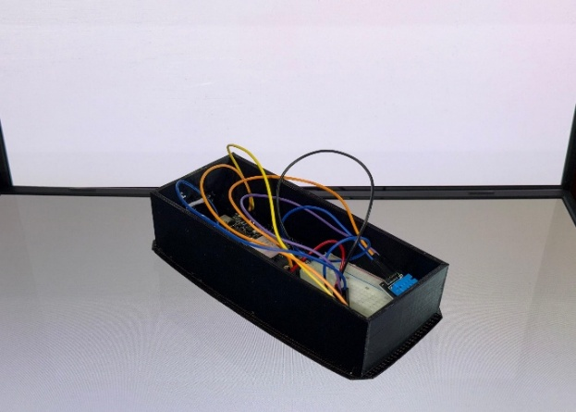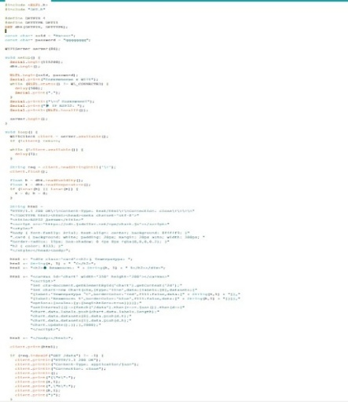

Progress of work:
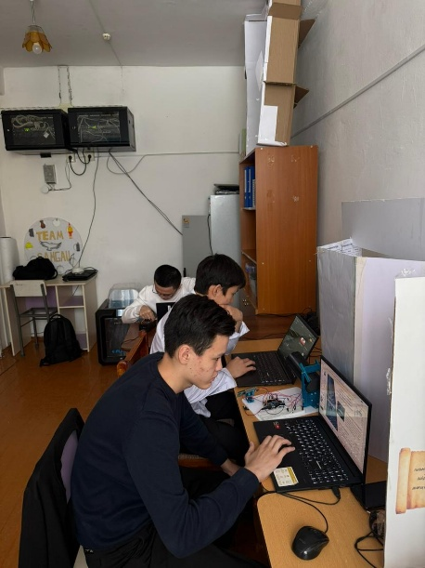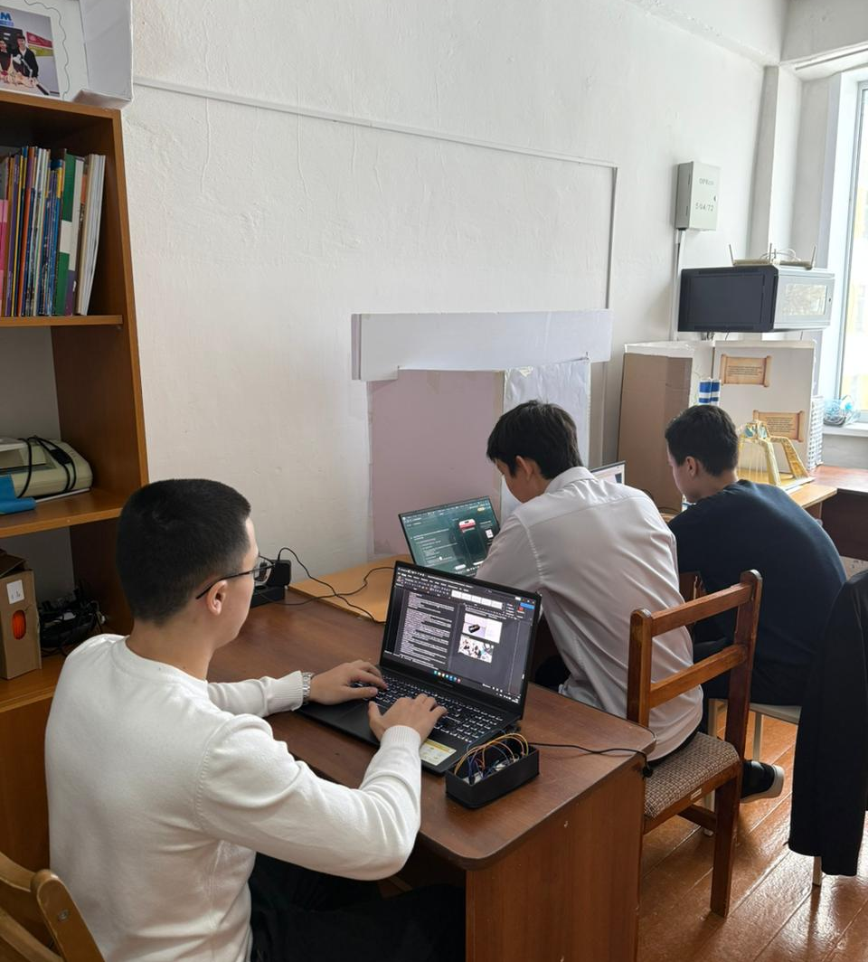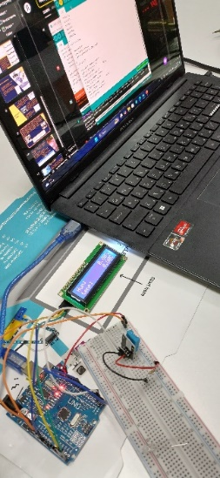

Conclusion
In this work, we studied the activity of the sun and its impact on the Earth and Man, and identified the changes that it causes in the human body. We learned about the actinometer, a device that monitors solar activity, assuming that we can recognize these changes in time and reduce the harmful effects. First,we created an actinometer, a device that monitors solar activity using the ARDUINO UNO set temperature sensor(DHT11), an Arduino Uno circuit board, Mom-Dad, Mom-Mom ESP32 wires, and an ARDUINO UNO set. We used our developed actinometer ESP32 and ARDUINO UNO set temperature sensor(DHT11), Arduino Uno circuit board, Mama-Papa, Mama-Mama wires. Based on the data obtained by the thermodatchik, we believe that when solar activity increases, it will allow people to take measures to reduce their harmful effects, for example, wear light clothing, wear glasses, go outside less for people with chronic diseases, etc.
Previously, we built the actinometer device on the Arduino platform. However, in this version, the data was displayed only through the display, and the functional capabilities of the device were limited. Therefore, in order to improve our project, we decided to create a new version based on the ESP32 microcontroller.
The main advantage of ESP32 is the presence of built–in Wi – Fi and Bluetooth modules inside it. This feature allows you to wirelessly send data to your smartphone or other devices, as well as monitor it in real time. Thus, we were able to control the device through the phone application and see the results directly from the screen
This innovative solution allows you to receive and analyze data remotely, increasing the comfort of use of the device. In addition, the use of a phone screen instead of a display makes the device compact, energy efficient and modern.
Thus, in order to reduce the harmful effects of solar activity on the human body, it is possible to use the actinometer device, and we believe that our prototype will become an indispensable tool for it.

List of references
- National library of medicine https://pmc.ncbi.nlm.nih.gov/articles/PMC9976694/
- https://www.technoprocur.cz/data/files/Tomas/Chemact.pdf
- Emission, thermocouple, and electrical measurements in SF6/Ar/O2 SiC etching discharges | Journal of Applied Physics | AIP Publishing
- Б.М. Владимирский, Н. А. Темурьян, В. С. Мартынюк М./Космическая погода и наша жизнь. / - Век 2, выпуск 2,2014. - 224 с.
- А.Л. Чижевский М. - Космический пульс жизни: Земля в объятиях Солнца. Гелиотараксия."Мысль", 2015г. - 766 с. /
- В. А. Колжиков, А. М. Оводенко /Солнце и его влияние на жизнь Земли. / Уникальные исследования XXI века. 2017. № 5 – С. 85-92
- Ғарыш туралы барлығы. 2016. Әлемнің саяхаты. Баспа қызметін елестетіп көріңіз.
- Бұл қалай жұмыс істейді. 2016. Ғарыш кітабы. Баспа қызметін елестетіп көріңіз.
- Остер, Л. 1984. Қазіргі астрономия. Редакциялық реверте.
- Википедия. Герцпрунг-Рассел диаграммасы. Қалпына келтірілді: es.wikipedia.org.
- Википедия. Жұлдыздар популяциясы. Қалпына келтірілді: es.wikipedia.org.
- https://helpiks.org/3-49519.html
- https://mash-xxl.info/info/397855/
- https://ru.wikipedia.org/wiki/%D0%90%D0%BA%D1%82%D0%B8%D0%BD%D0%BE%D0%BC%D0%B5%D1%82%D1%80
- https://poltraf.ru/solnechnaya_radiatsiya/Aktinometriya/piranometr_sr11/
- https://patents.google.com/patent/WO2011081548A1/ru
- Джереми Блюм – Изучаем Arduino. Инструменты и методы технического волшебства.
- Саймон Монк – Программируем Arduino. Профессиональная работа со скетчами.
- Юрий Менщиков – Ардуино на пальцах.
- Виктор Петин – Электроника. Проекты с использованием Arduino.
- Улли Соммер – Электроника. Программирование Arduino.

Link to work: https://youtu.be/YyZ6MGFAynE?si=dZymvGrATkQfSv0a

specialized gymnasium
for gifted children
named after Kanysh Satpayev
10th grade students Kaztay Alizhan, Zhalel Ulan,
Nuridenov Mansur
"Created on the basis of Arduino
through the actinometer of the sun
radiation level control work

Comment
In this project, along with theoretical material about the sun, solar activity, there is a lot of information about the actinometer, a device for studying solar activity. The influence of solar activity on the Earth and man is accompanied by statistical data. Today, robotic devices are widely used to make human life safe, as well as to facilitate it, and with the help of a device developed by Alizhan,Ulan,Mansur, it is planned to solve the problem of controlling the radiation level of the sun and preventing harmful effects. First with the LEGO Mindstorms set, then using the ARDUINO UNO set, he created the actinometer, a device that monitors solar activity. The ARDUINO UNO kit's temperature sensor (DHT11), Arduino UNO circuit board, layout circuit board, wires, led, buzzer and symbol display LCD 1602 were used. The actinometer allows people to perform measures to reduce their harmful effects when solar activity increases in everyday life, such as wearing light clothing, wearing glasses, going outside less often for people with chronic diseases, etc. Using the data obtained through the temperature sensor, preventive measures are taken. The device developed during this work improved the actinometer, and students tried to create a mobile type of actinometer, according to which if the actinometer is available as a glucometer, tonometer, the number of people suffering from solar activity will decrease.

Reviewer, Project Manager: B. V. Atik

